**Magento2 Installation Documentation**

**Pre-Installation Steps**

**Step1:** Download Latest stable magento2 release with / without sample data.

**Step2:** Create a folder with your application name inside your webservers deployment directory (Wamp: C:\wamp\www).

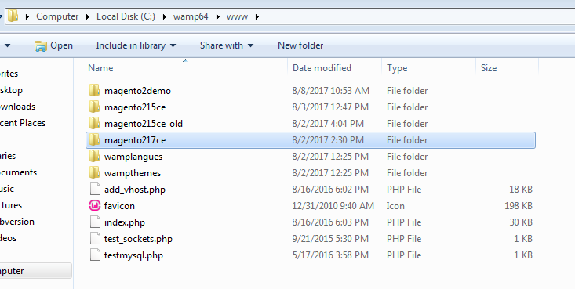

Paste the downloaded magento2 .zip file inside the newly created folder and extract there.

**Step3:** Create a virtual host for the application. Technically give an entry like bellow screenshot in httpd-vhosts.conf file and hosts file. This may differ with windows and linux.

**httpd-vhosts.conf**

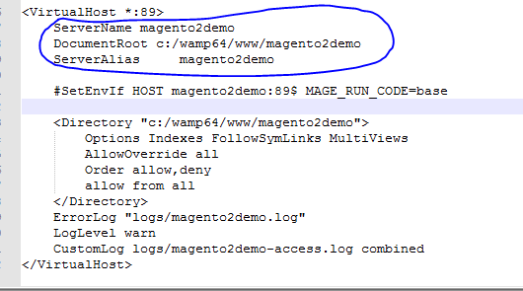

**Hosts file**

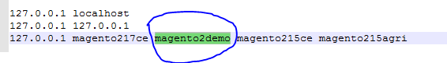

**Installation Steps**

**Step4:** Open the browser and hit the url with newly created virtual host **ex:** [**http://magento2demo:89/**](http://magento2demo:89/) **,** will get the bellow screen

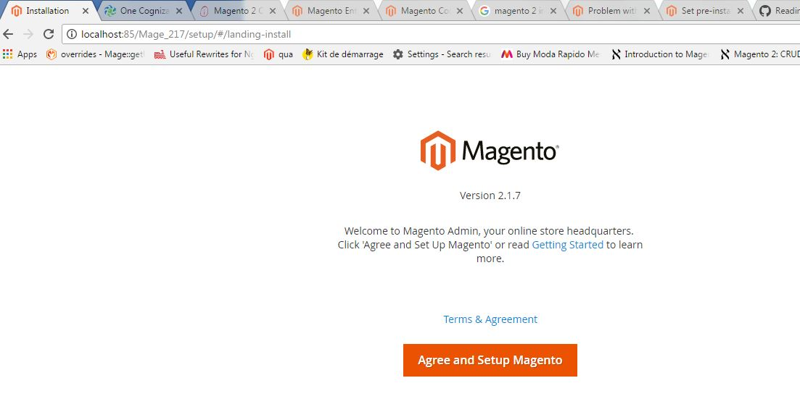

**Step5:** Click on **Agree and Setup Magento** button to continue with the installation. Bellow Screen will appear. In this screen Magento will validate the software requirements.

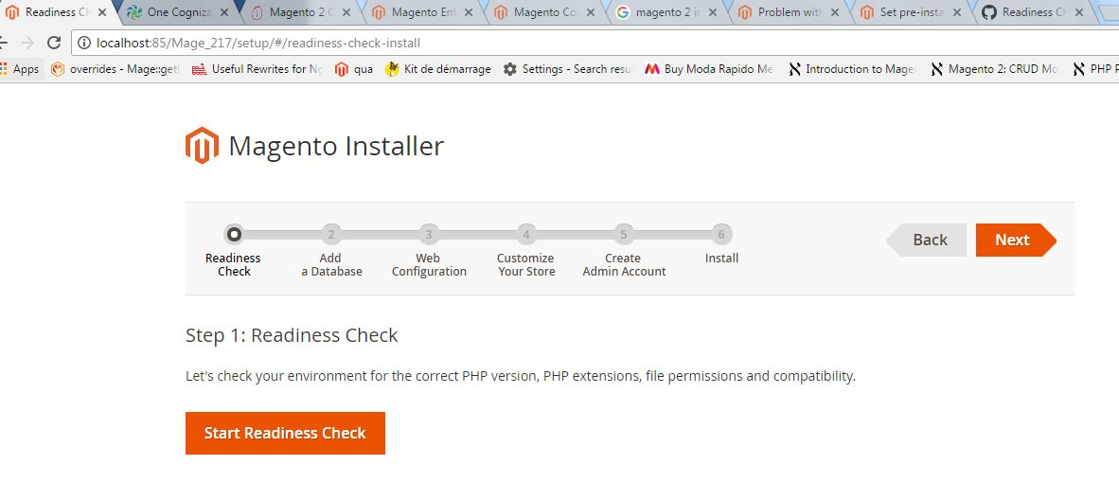

**Step6: Readiness Check.**

Click on **Start Readiness Check** button to validate the system.

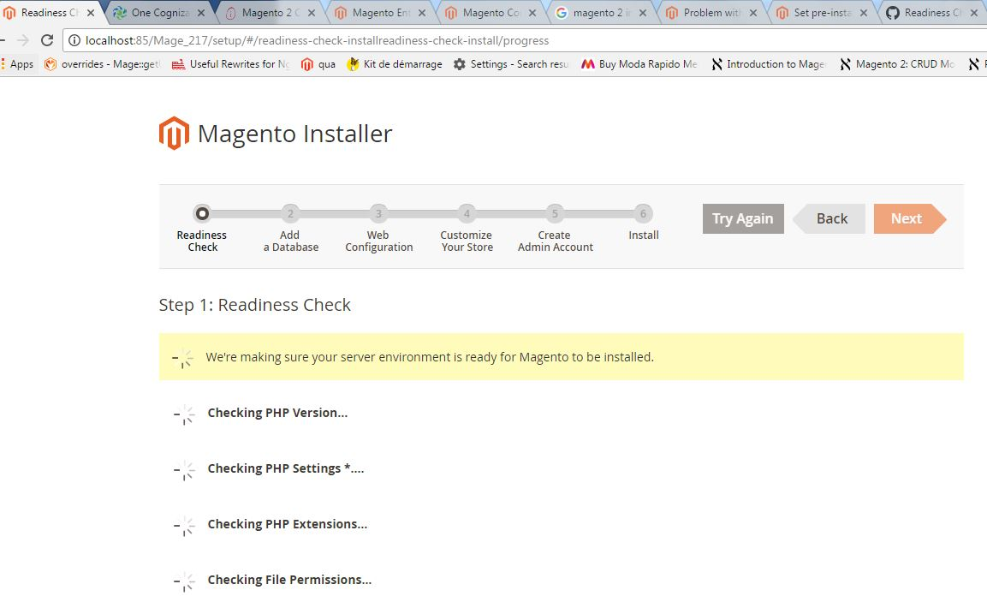

As a result Magento will display few screens

**If the server not responded properly**

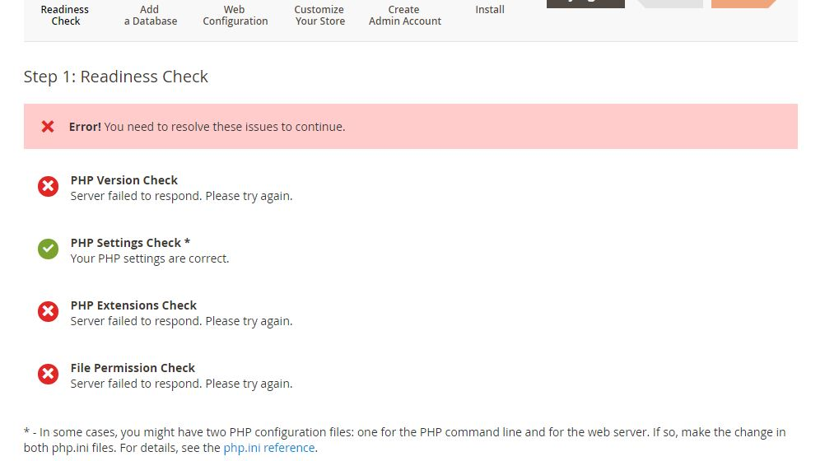

If we get this screen while installing, Recheck the system configurations like RAM installed, Speed of your computer and check the INI settings of PHP, MySQL and Apache.

For Php.ini settings, Check max_execution_time, memory_limit variables and reset them.

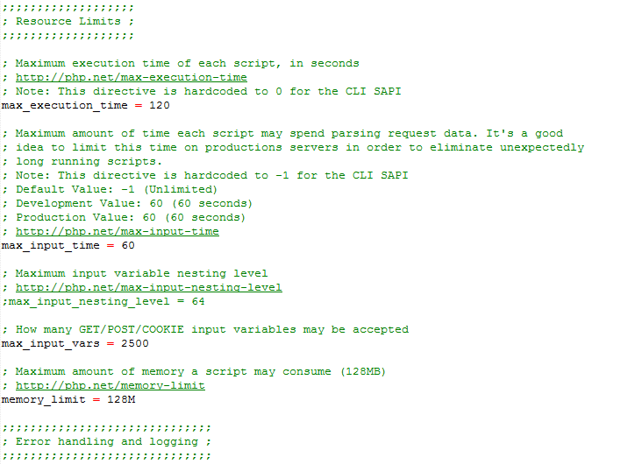

For my.ini settings, check the innoDB settings. Magento2 installs all InnoDB tables

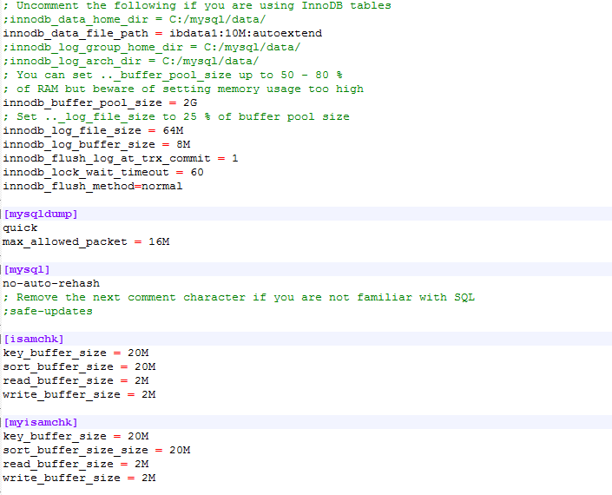

My.ini for other memory settings

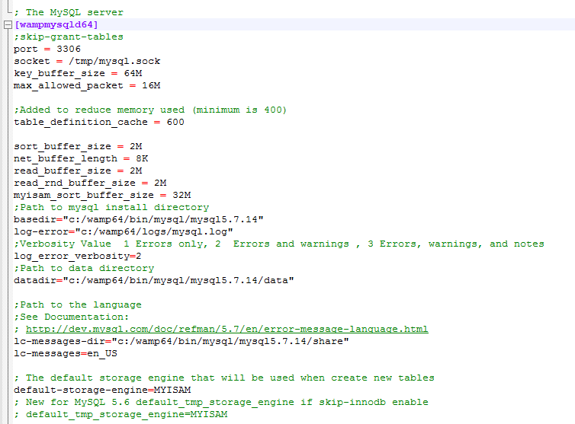

These PHP and MySQL settings will play key role in the performance of magento2.

**Server responded, but in php.ini modules not enabled**

Readiness check will let you know whatever the modules you need to enable to install magento2 on your server, check with the bellow screenshot.

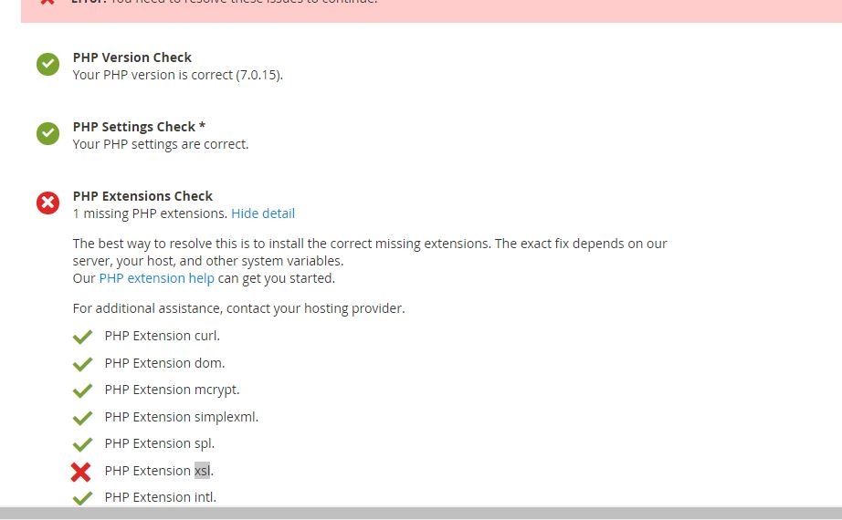

**If Readiness Check success,** Bellow screen will appear

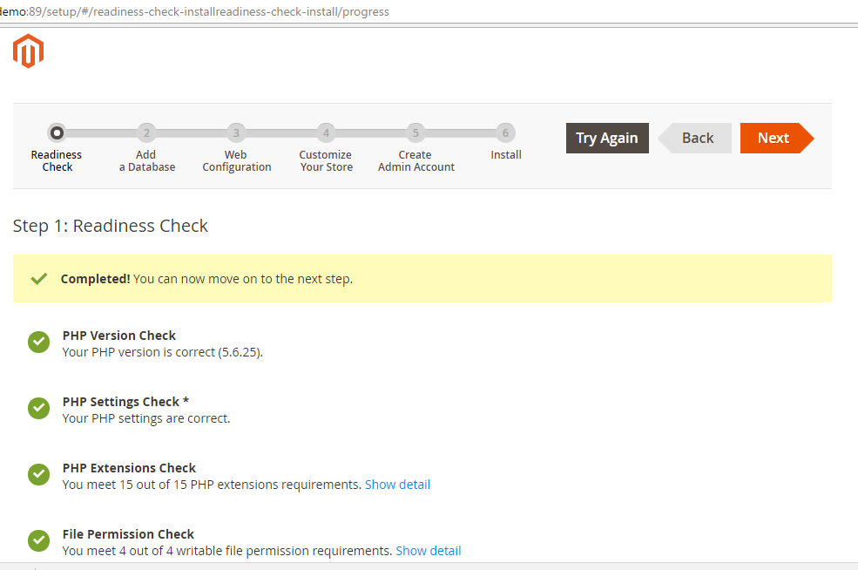

**Step7: Add a Database.**

Click on **Next** button to continue installation. It will ask you to provide database server details.

Provide the host, username / password and the database you have created. Make sure you have created the database on the MySQL server already. It will verify and install the tables on that database. It will not create database if not created and stops installation. For DB follow the second screen shot in this step.

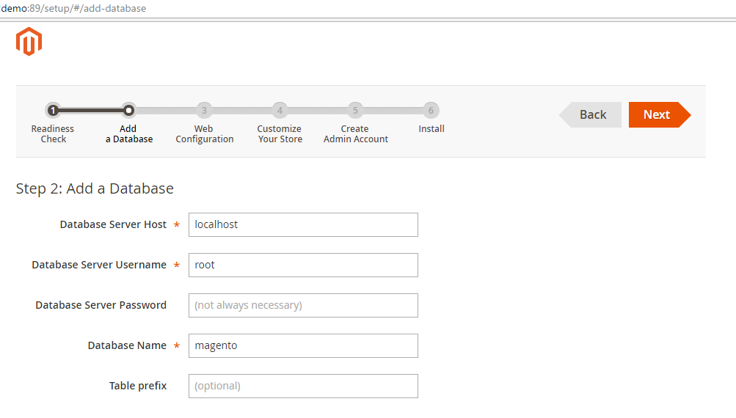

**DB on MySQL Server**

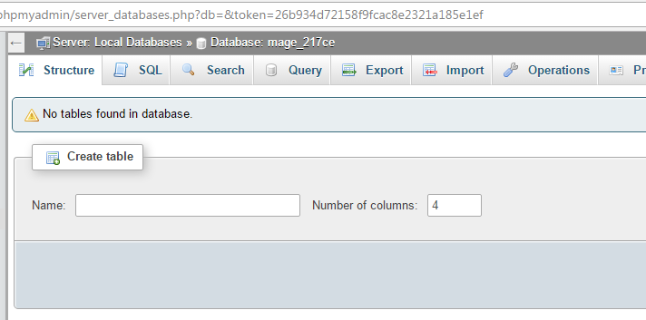

**Step8: Web Configuration.**

After giving the DB details click on **Next** button. In this step you can select advanced web configurations also. Verify the Store address and Magento admin address.

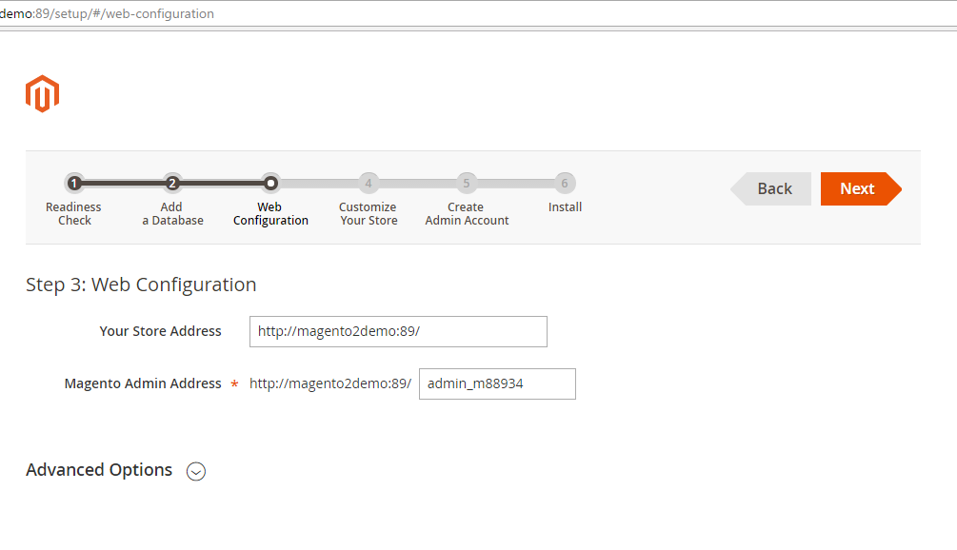

**Step9: Customize Your Store.**

Give the Store specific configurations like time zone, language, currency and modules you wanted to install.

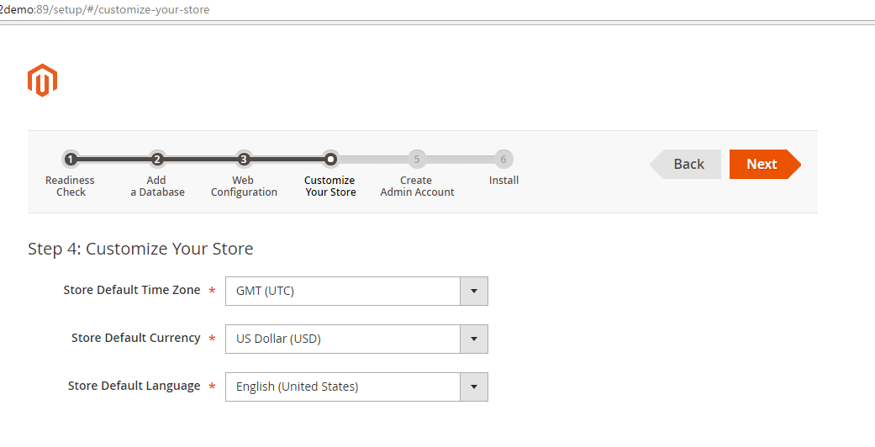

**After Few Seconds**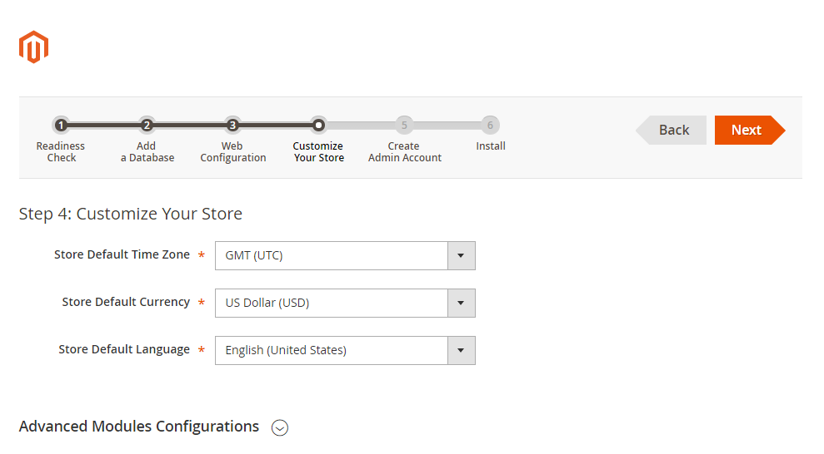

**Step10: Create Admin Account**

Create a Magento Back Office account and click on next to continue installation.

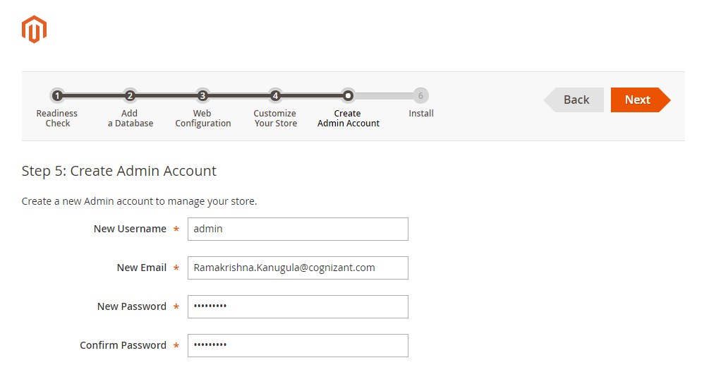

**Step11: Install**

Click on Install button on the screen

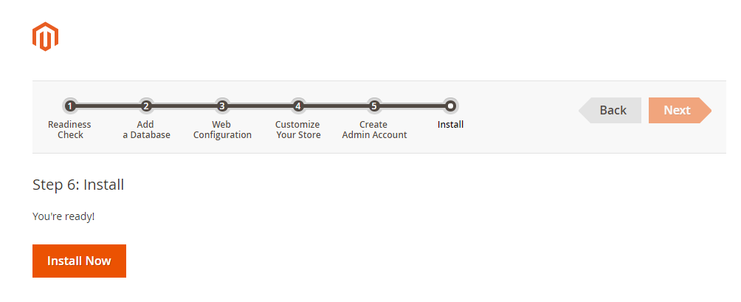

**It will display the progress of installation**

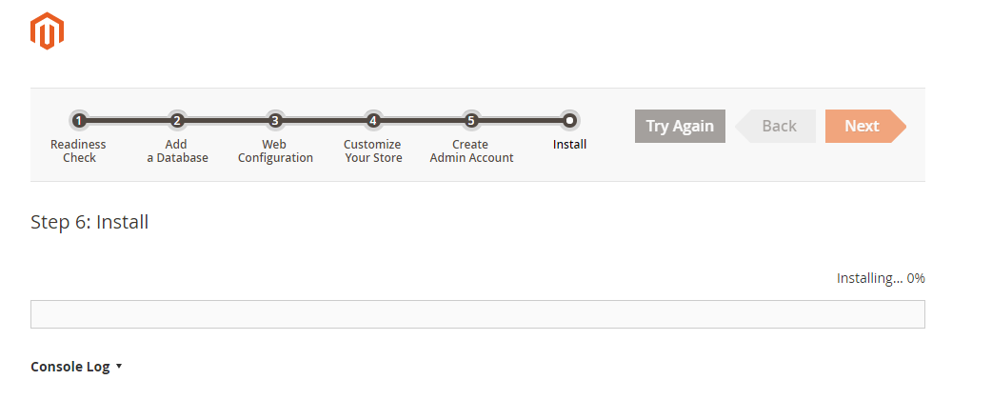

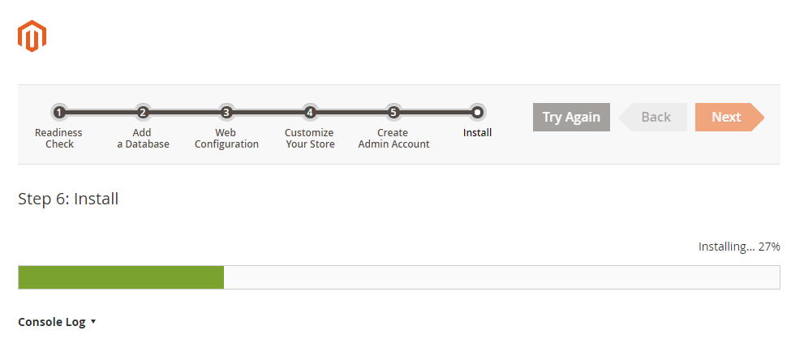

Once the installation is completed bellow screen will be displayed with the details of Store and Magento Back Office. **Don’t click on the links**. Before clicking need to follow some post installation steps to load the site and admin screens smoothly and fastly**.**

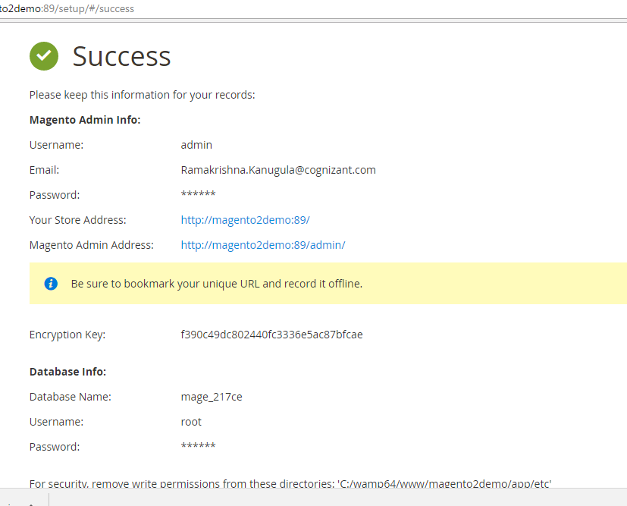

**Post Installation Steps**

**Step12: Open Your Terminal / Command prompt** and change the path to your application bin folder and run the commands

***php magento cache:clean*** *.* This will clean all the cache types

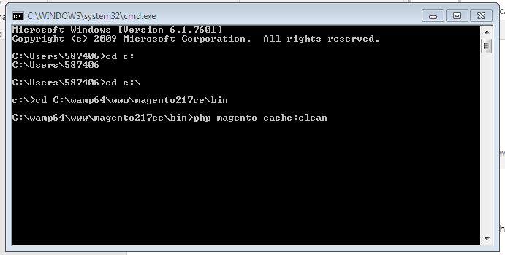

***php magento indexer:reindex*** This command will reindex all the indexes***.***

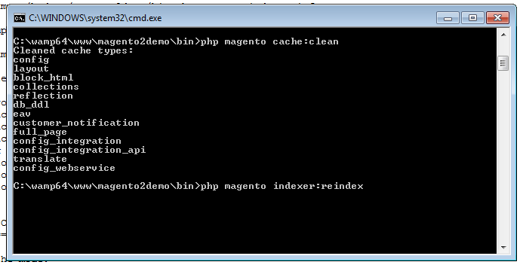

***php magento deploy:mode:set developer*** If you are going to work on the themes / modules as developer you have to change the mode. Infect this will slow down the performance.

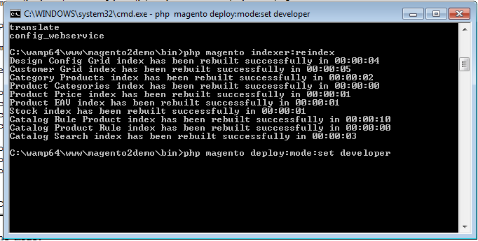

***php magento setup:static-content:deploy*** This is very important, This command will compile all the magento themes produce static content and deploy the static content. While running the site magento will pick the content from the static files but not from the source files.

This command will take around 1hr to compile and deploy the static content.

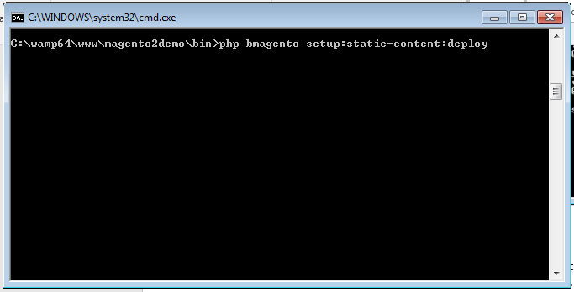

Now we are ready to open the URLs in the browser.

Just Open the Store and Admin Urls in the browser and check whether magento2 is working or not.

For Store : <http://magento2demo:89/>

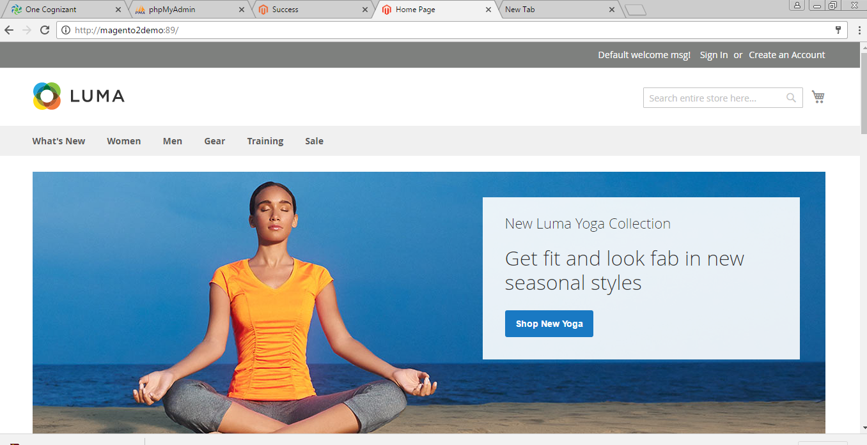

For Admin : <http://magento2demo:89/admin/>

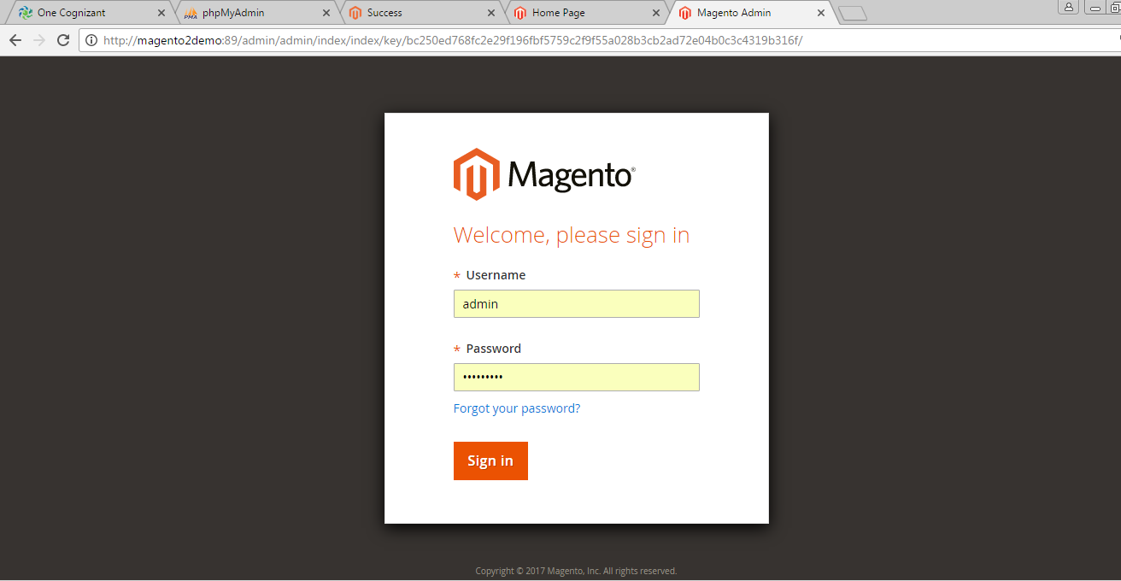

Give the credentials. We have created admin account while installing.

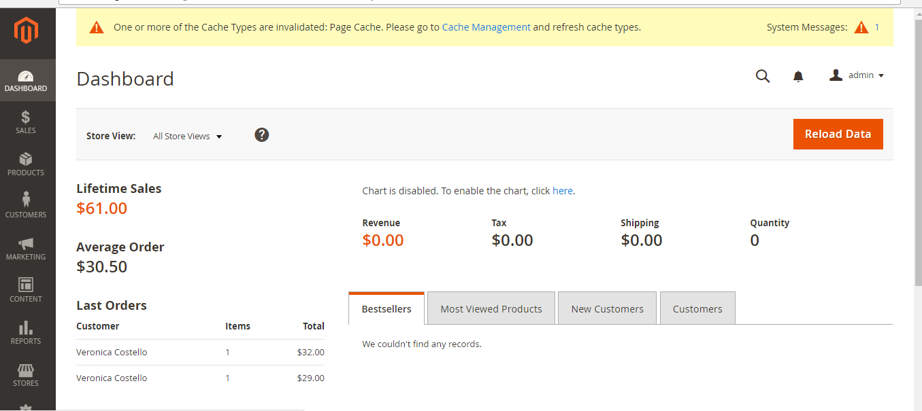

**That’s it!!!!**